Observation

1. 

This statement shows that I opened the gitbash at the desktop

1. 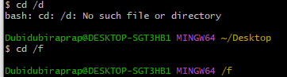

Here I tried to open my D drive but as the gitbash response there is no D but F

1. 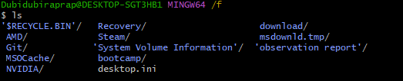

Here I checked what’s on my F

1. 

Here I create a folder under my F drive named raprap

1. 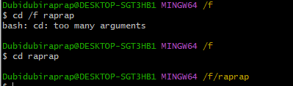

Here I opened the folder I created

1. 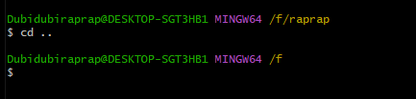

Here I used the 2 dot to go back to my previous folder

1. 

Here I created a text file raprap.text inside raprap folder

1. 

Here I cleared all the line

1. 

Here I checked the text file I created inside the raprap folder

1. 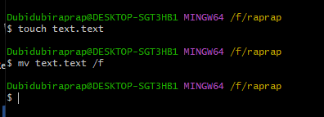

Here I created another text file then move it F drive

1. 

Here I go back to my previous folder/directory then remove the text file

1. 

Here I Also remove the folder/directory raprap